**Assignment 1 : Simple SQL Query with a single table with where clause.**

**Write a query to get a Product list (id, name, unit price) where current products cost less than $20.**

**:-**

select ProductID as ID, ProductName as Name, UnitPrice as Price from Products

where UnitPrice < 20;

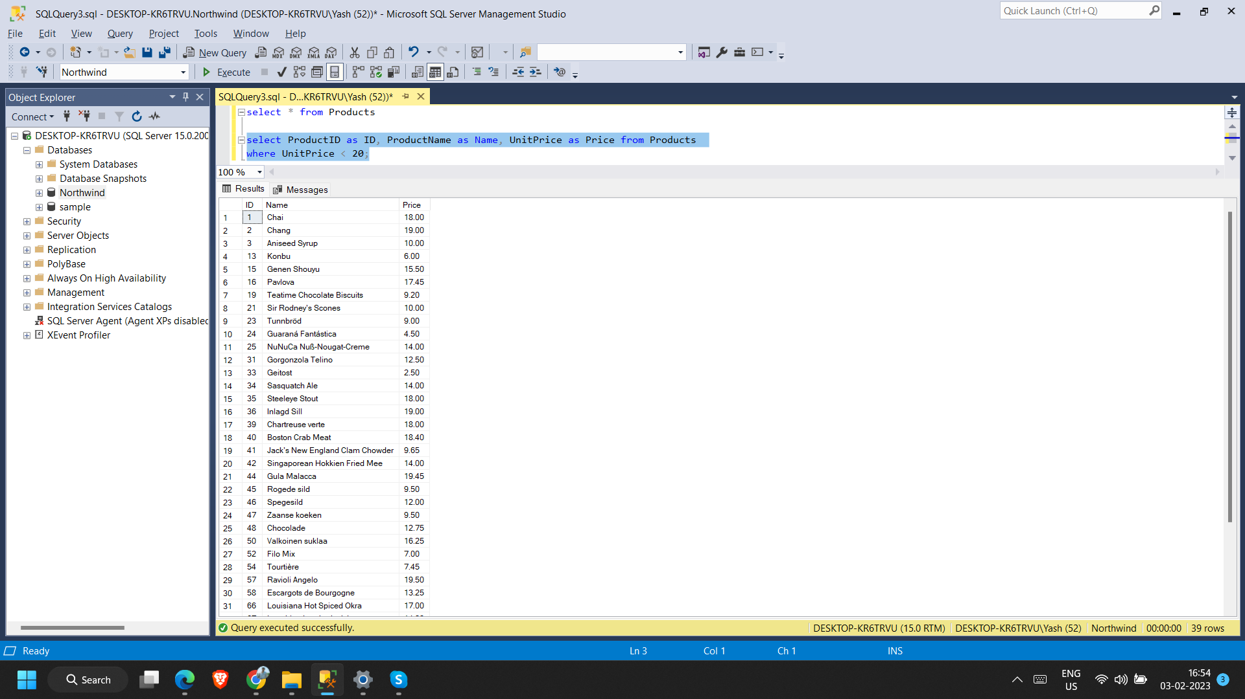

**Write a query to get Product list (id, name, unit price) where products cost between $15 and $25.**

:-

select ProductID as ID, ProductName as Name, UnitPrice as Price from Products

where UnitPrice <= 25 and UnitPrice >=15;

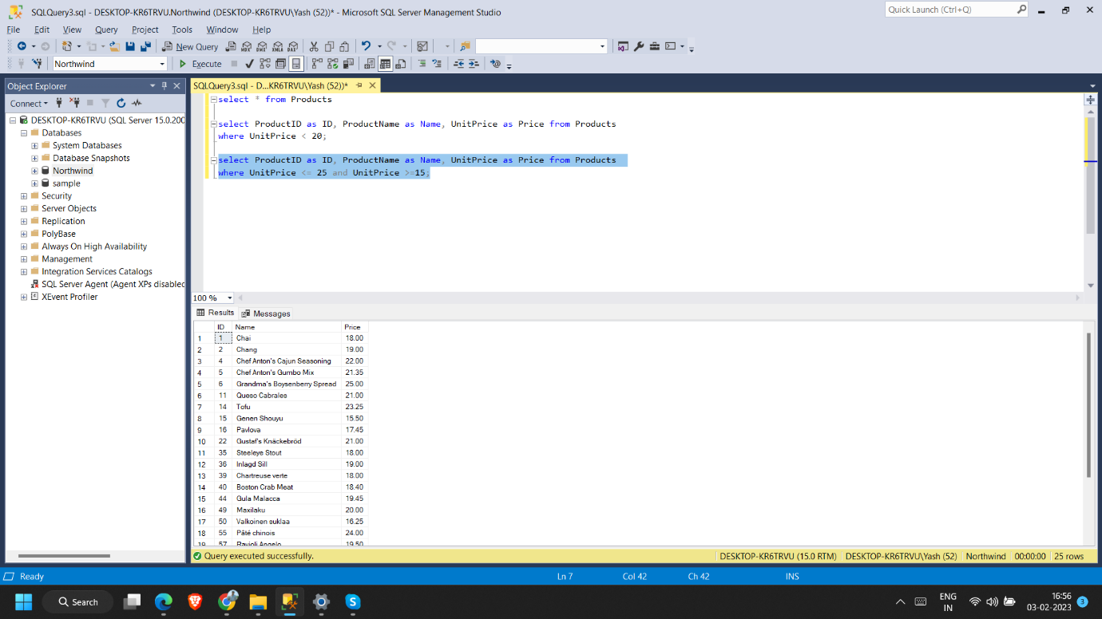

**Write a query to get Product list (name, unit price) of above average price.**

**:-**

select ProductName as Name, UnitPrice as Price from Products

where UnitPrice > (select avg(UnitPrice) from Products) ;

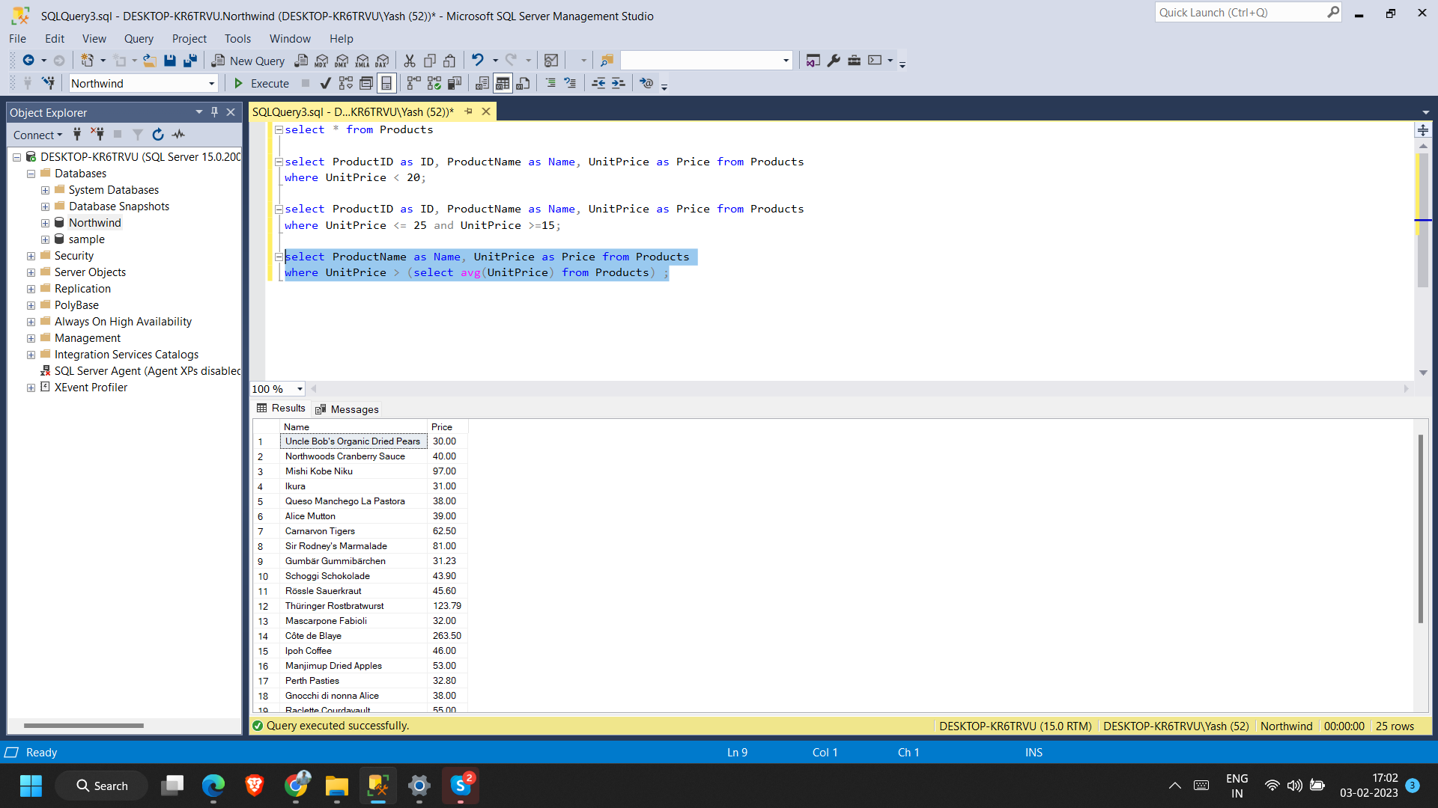

**Write a query to get Product list (name, unit price) of ten most expensive products.**

**:-**

select top 10 ProductName as Name, UnitPrice as Price from Products

order by UnitPrice DESC;

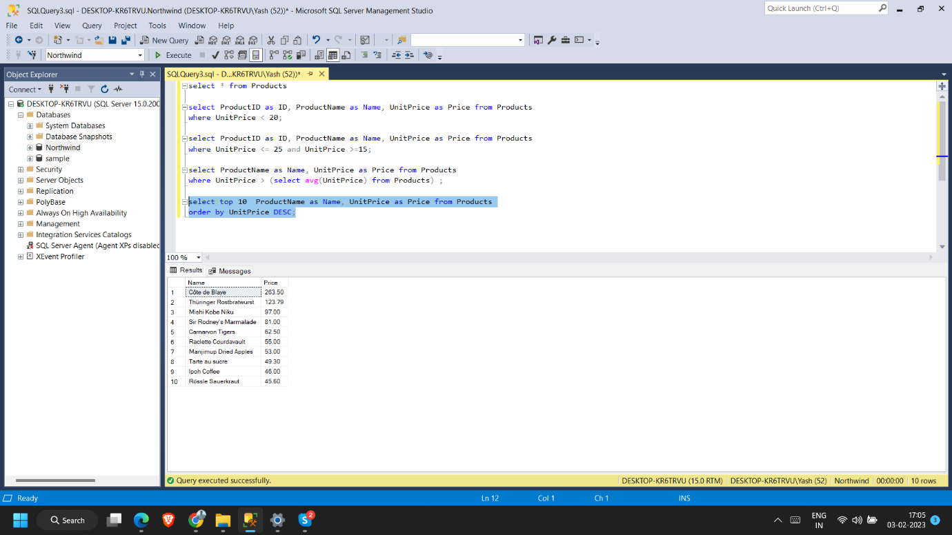

**Write a query to count current and discontinued products.**

**:-**

select count(Discontinued) from Products

where Discontinued = 0;

select count(Discontinued) from Products

where Discontinued = 1;

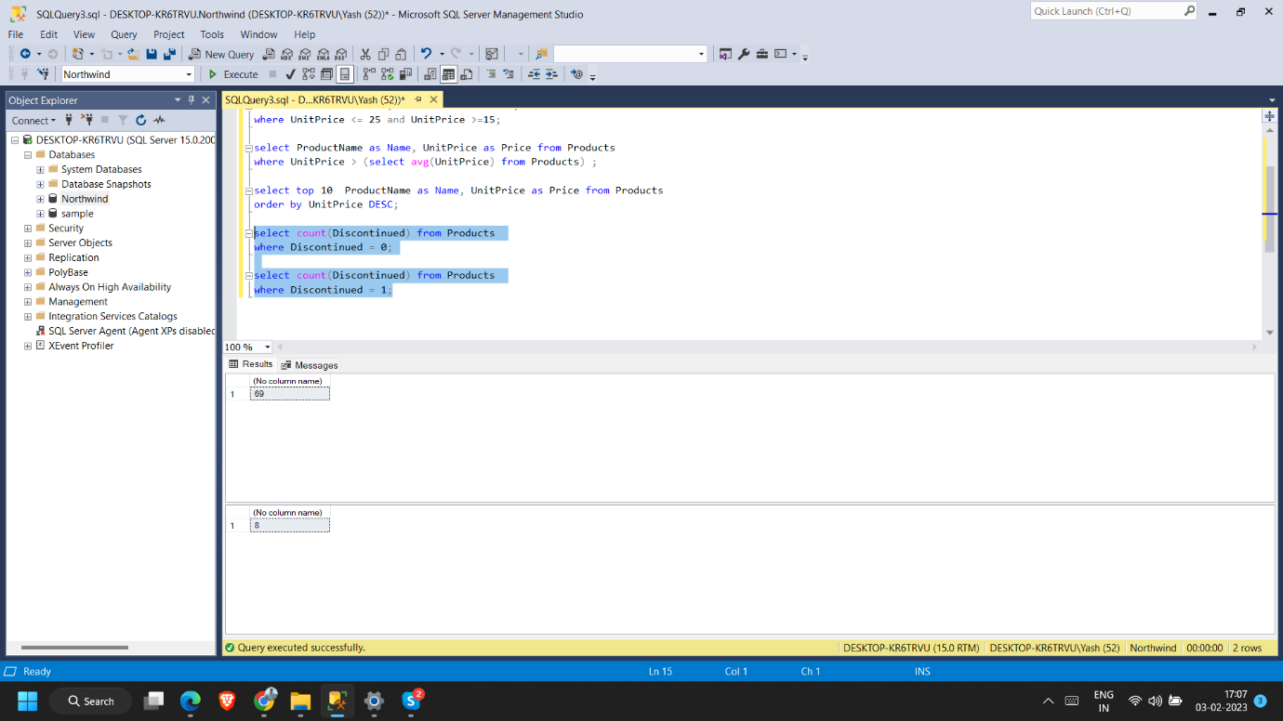

select Discontinued,count(Discontinued) as numberofproduct from Products

group by Discontinued;

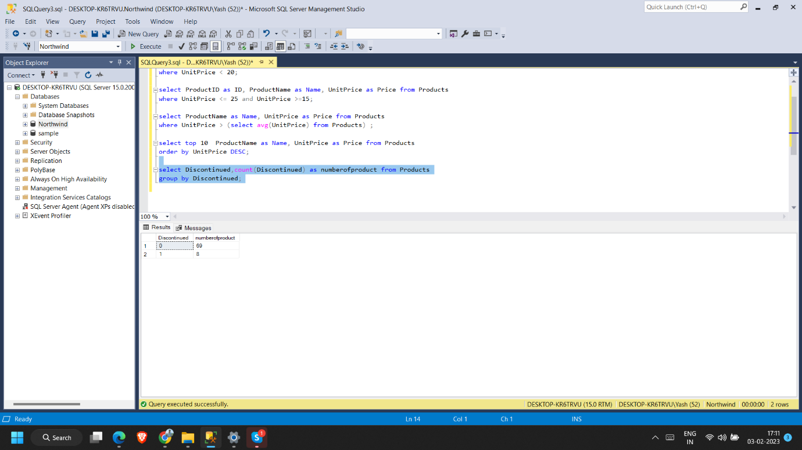

**Write a query to get Product list (name, units on order , units in stock) of stock is less than the quantity on order.**

**:-**

select ProductName as Name,UnitsOnOrder as [units on order] , UnitsInStock as [units in stock] from Products

where UnitsOnOrder > UnitsInStock;

